West Hull Ladies
RRC

June Newsletter
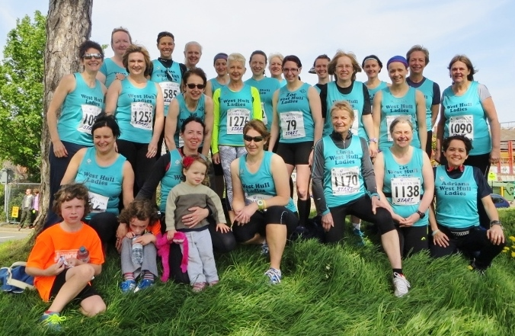

West Hull Ladies

WEST HULL LADIES RRC COMMITTEE MEETING

1st June 2015

Present - Jill, Zoe, Amanda. Sandra, Maria, Karen, Andrea, Lynne, Liz, Rachael

- Apologies were received from Jan, Linda, Annette
- Minutes of previous meeting accepted as true record
- Matters arising - Karen to continue enquiries concerning websites showing our name as West Hull Ladies Runners. Discussion about various websites Run Britain, power of 10 etc. Agreed it would be useful for all the info to be collated and forwarded to club members. Action - Karen kindly offered to do this.
- Sandra updated on the GBR - the dates had moved on by one month. Our leg was to take place on 5th August - still a Wednesday and still at 3.37pm. Action - Andrea to update pinned post on Facebook with new details.
- Maria informed the committee that 2 ladies had bought vests at the reduced rate. Several members had tried the sample vest and were happy with it. Further ladies to wear before decision made. Action - Rachael to find out the exact Pantone Colour for perfect match.
- Facebook was causing some concern as it was felt we were a closed group for a reason and many members of the FB group were not known to any club members. Agreed that the opening paragraph on FB be revised and that Admin were to use their discretion on who to allow and who to ‘cull’. Action - Andrea and Karen as above.
- Karen had discovered that several leaders were not DBS checked. Action Karen to make further enquiries.
- A social evening was planned for 6th June 2015 and it was hoped that we hold another in July. Action Jill to liaise with Linda as regards a suitable date.
- Members enquired as to the extent of the insurance cover Run England provided for our club. If we competed in track and field events were we covered? Action - Karen to verify with Run England. Amanda updated on the Hull Marathon - some 1000 people had entered. The organisers were asking if anyone had tables for the water stations - gazebos, a megaphone?

Meet a Member: Karen Scott

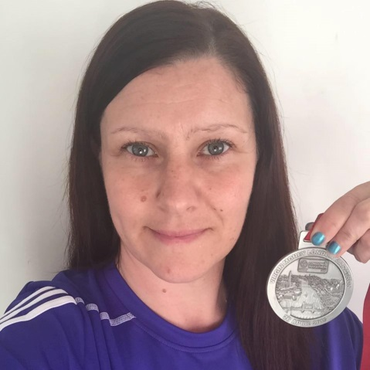

Age: 42
Member of WHL since: August 2009
What do you do when you’re not running?
I am wife to Paul (18 years in August), mum to Georgia and 2 gorgeous black & tan cavaliers and part-time teacher at a local special school coordinating PE. As a family we have recently moved house which already feels more like a home in 4 months than our last house of 12 years ever did…

How long have you been running?
Since April 2009
Why did you start running?
It was all about losing weight. The numbers on the scales had got pretty scary so joined a local slimming club and started to use a ‘0 to 5k’ app. At the time the thought of running for 3 minutes seemed impossible…

Favourite distance?
I don’t really have a favourite distance. I’ll run anything from park run up to marathon.
Favourite bit of running kit
I have 3 items I really can’t run without – Garmin watch, trainers and my dutiful running bra!!! No particular order but I tend to ‘need’ all 3 to run.

Any injuries?
My last big injury was in 2011 whilst I was training for my first marathon. I ended up needing physio to get me to the start line. The training goals had really stretched me at the time which led to me losing all motivation to run. Now I tend to train within my ability and not beyond. I also don’t run more than 2 days in a row and have regular physio sessions to keep me moving.

Running goals?
- To run regular.
- To run for enjoyment.
- To run a sub-5 hour marathon!
Proudest moment running related or otherwise
Finishing all 3 marathons I got to the start lines for.

Best piece of advice you’ve received
Run because you want to not because you have to.

Running alone or with friends?
I can do both but much prefer to run with friends!

What keeps you motivated?
I know it sounds cheesy but all of the West Hull Ladies. They are not just ladies I run with but ladies I’m proud to call my friends. Also knowing I can just get up and go out for a run is motivation enough sometimes…

Meet a Member: Jill Jameson

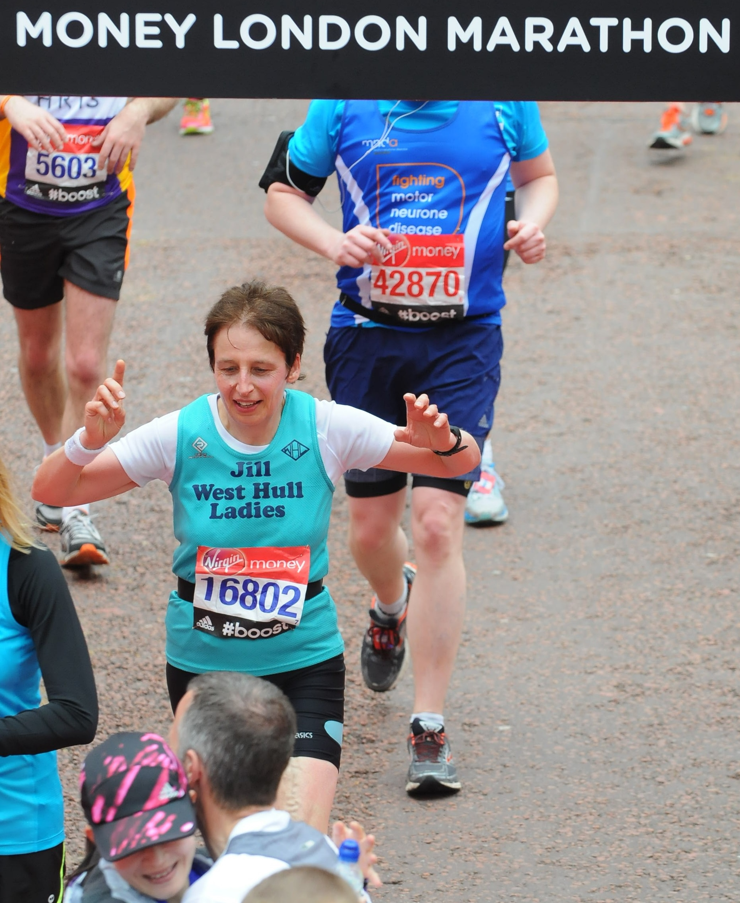

Age 54

Member of WHL since
2012
What do you do when you’re not running?
I've worked at the University of Lincoln as a lecturer in Criminology since 1996, but decided not to move to Lincoln because I did not want to move son Michael from his specialist autistic education in Hull. I have three children, all now in their 20's, Kim who is a musician in Manchester, Zoe, who we all know and love and is still at home! And Michael who now is in supported living in Brough. When I have time, I like drawing, riding my motorbike, cycling, mountain biking, playing rock guitar, collecting antique pottery and getting out in my garden.

How long have you been running?
since about 2003
Why did you start running?
I was thirteen and a half stone and hit a mid life crisis, so I changed my diet, and after losing a bit of weight went out running with Kim and Zoe who were practicing for a school event. I lasted about 400 metres, but a few days later, went out on my own and ran a mile, which was the start of it all.
Favourite distance
either 10k or half marathon.

Favourite bit of running kit
my compression socks.
Any injuries?
How long have you got lol! lots of niggles, but try and manage these by being careful with my training and using rock tape to stop bits falling off! The problems are usually all associated with my right leg, from my bunion, niggling Achilles, dodgy knee and calf and slightly stiff hip, but I try to listen to my body because I still want to be running at 80. I've lost various toenails too, but it really isn't that bad!

Running goals?
To get faster, but always to finish feeling okay, and to carry on running into my 80's.
Proudest moment running related or otherwise
Finishing the London marathon, but also daughter Zoe winning the Thunder run with Sally.

Best piece of advice you’ve received
Do a body MOT on your style every mile or so on a long run (Sandra); and professional runners don't go for PB's every time they run, so we shouldn't ever be disappointed if we don't get a PB (Jamie Barrington).

Running alone or with friends?
Either.

What keeps you motivated?
The camaraderie of the running club, and the feeling of achievement when you cross the finish line or finish a run.

Beverley ten k : Amanda

Beverley 10K marked my first race of the year (barring Champagne League races). This was due to a promise to my hubbie to focus on cycling this year and therefore the longest race would be a 10K. Running then took an even more back seat when I developed plantar fasciitis [Wikipedia: Plantar fasciitis is a common painful disorder affecting the heel and underside of the foot]. It was never totally painful but uncomfortable and as the cure is to rest it I did as little running as possible… inbetween giving it all at the Champagne League. Thankfully, after over 7 weeks I seemed to turn the corner and it is improving but a lot of missed training.

This meant I came to the Beverley 10K without the pressure of aiming for a PB. My hope was for sub 45 mins.
I was looking forward to the race as there were so many WHLs running. A few were our 0-5K runners who, with our encouragement and their determination, had put their name down and were running their first ever 10K. Others looking for a PB. Some just to enjoy themselves (Carol ).

Time to head to the start. I wriggled my way through the crowds as I know you can lose a lot of time finding your pace if you are having to weave around runners. Still a little over crowded when we set off but soon had some space and seemed very quick to reach the Westwood. K markers and M markers, the distance ticked over! We had great running conditions with only a minor complaint about the headwind on the hill but I managed some shelter behind a big chap for at least half of it. I think I made him nervous, he kept trying to move away from me.

The PF was squeaking as I reached half way but did not seem to be getting worse so I tried to ignore it. Walkington lights and the biggest cheer ever from the champion cheerers Tracy C and Sarah K. THANK YOU GIRLS. Had me smiling for the next half mile. This section always seems quite long but when you reach the cattle grid you feel like you are reaching home. A young lass passed me along this section. I realised it was Emily and she looked great. Really strong. Down over the Westwood, mile 5. Trying to maintain the effort. Got calls from various people which was really appreciated.

Finally into Saturday market and the cobbles. Not too far now, keep up the effort. Taking the racing line on the last bend a young lad a few strides ahead stopped dead, head down and threw up. Good effort eh? I jumped sideways to avoid going over him and pushed another runner out of the way who apologised to me! Just a few more meters and under the timer, no question about sub 45 mins.

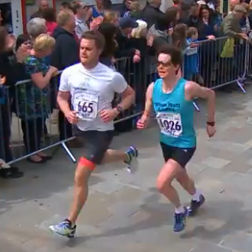
Number 665, despite classic over striding, beat me!

Really pleased with my time 44:32 and being 1st FV55 and being 17th lady out of 548… despite my age. I am proud that I still can produce a good time. It doesn’t come without working and although I won’t be doing a lot of running this year I will be keeping up one or two ‘quality sessions’ each week.
Hoping for even better in the Humber Bridge 10K which looks like another bumper WHL turn out.
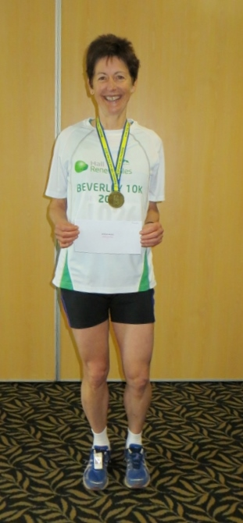

Beverley ten k : Jill

Being like the cat that got the cream…or the PB in this case, I went into the Beverley 10k a week later, wondering if I could do it again. Whilst my body is always a bit creaky, even at its best, I was wondering whether I could tackle it in the same mindset that I had done for the Half marathon…so this time I was thinking …I only have to run to the Cutty Sark…should be a doddle (well relatively speaking!). Of course no race is a doddle, and 10k’s are hard work, particularly up the hills from Beverley. Sandra said a very true thing to me after the event, in that she said that in longer races such as half marathons, there are always parts that you can enjoy, but with 10k’s because the effort is so intensive, its always tough going…and it was. Again I was quite pleased how good my legs felt and when I caught daughter Zoe at the second water station, I was a bit in shock if I’m being honest. I actually started to pull away from Zoe until she decided that she couldn’t possibly let ancient parent beat her, and she passed me and ran off into the distance! Drat! I had also been playing cat and mouse with Suzanne from the Sunday girls cycle club, who was running really well. When we hit the main street Suzanne decided to sprint away from me, but misjudged the finish. Fortunately for me, I knew exactly where it was and almost got her back, although she just pipped me on the line. I was again really chuffed as I had achieved another PB for 10k this time at 51:23, with the creaky body still holding up, although toes looking a bit the worse for wear still (not a pretty sight!). It was a day of PB’s for lots of our whl’s which was fantastic. Amanda won her age group, awesome! Despite this being a really tough course too, we had well over 30 runners out, which was amazing! Great support on the route from Verity, Sarah K and Jermaine. All in all a really great day again. I’d like to say that doing marathons is good for me…but I’m trying not to tempt fate here and I’m doing a lot of wood touching in the hope that I stay fit for Endure and the Thunder run…eeek!
Jill

Beverley ten k : Andrea

Well, what a difference a week makes. Compared to last Sunday (North Lincs Half) the weather was positively tropical. I decided I didn’t need gloves, ear warmers, long tights or long sleeves. Or a change of clothing for the way home – how liberating!

I’d managed to persuade my husband and daughter to come along and support me and I was very grateful to have someone there (if only to carry my bag! – just kidding – although he did carry my bag) we arrived at the leisure centre in good time, so I was able to chat to some of the many West Hull Ladies who had entered to race and to have one last toilet visit. I was feeling quite nervous as last weeks half marathon had left me feeling low on confidence. I’d trained properly for it and I knew it would be a challenge, but it took me by surprise how early on I’d struggled, I’d considered backing out, but knew I’d feel worse if I did. After all, this was ‘only’ 10k, a distance I’ve run lots of times. So, at 11 o’clock I found myself following the crowds to the start. I chatted to Liz and Christine and Sarah C; I positioned myself towards the back of the crowd around the 60 minutes plus section and then the crowd started moving forward and we were off. The first bit through the centre of Beverley was lovely – lots of support and cheering and clapping. I managed to spot my husband and my daughter (who was eating a huge chocolate ice cream) We soon left the crowds and turned up the road to the Westwood. I stayed with Liz for about the first mile and then she pulled ahead. I’d done a recce the year before so knew that the first bit was a drag up a hill on the Westwood, followed by a shorter hill. I concentrated on keeping going, small steps, swing your arms (thank you for the coaching Amanda) and was pleased when I got to the top without stopping as some people around me were walking. I managed to keep my pace fairly steady the whole way round and actually enjoyed myself. Maybe it was because I’d dreaded it so much that it could only be better than I’d imagined! I was surprised how quickly the miles and the Ks passed. The support along the route was fantastic, from strangers and from the lovely West Hull Ladies who’d turned up. Sarah K and Tracey really made me laugh jumping up and down and screaming encouragement. Then there was Jermaine on the Westwood and Verity and Sam outside the pub (how sensible!) It was absolutely brilliant to see you all and all your encouragement really gave me a boost. (I’m sorry if I’ve missed anybody!)

I passed the 9k marker – only 1k to go! and the route headed back to the crowds in the town centre. Wow there were hundreds of people! The atmosphere was amazing – but where was the finish?! The last stretch seemed endless. I ran passed the timing clock thinking that it couldn’t be much further – but it was! Finally I reached the finish and saw all the lovely smiling faces of the West Hull Ladies who’d waited to cheer everyone home and also saw my husband and daughter. Family, friends, water, medal, fruit, chocolate and a lovely t shirt – everything you want at the end of a race. And the icing on the cake was a pb. My chip time was 1:07:36 and having checked my old race numbers (I write my times on the back of them) is (I think) an improvement of over 5 minutes on my previous best time of 1:13:01 which was the Hull 10k last year.

I really enjoyed the race and will definitely do it again. Congratulations to the rest of the West Hull Lady runners.
Andrea

Beverley ten k : Anna

I have enjoyed the Beverley ten k in the previous 2 years, and this year proved to be no exception. We regularly have a huge team from the club, its my favourite distance, and always a good day out.
I also forget how pretty Beverley is. We were getting ready to run underneath the Minster, with all that history around us. Running through really quaint streets and past such charming houses is a treat.
I set off with the mile pacer, and kept up with the pack until half way along the Westwood, but wasn't enjoying it. I had had to keep telling myself it was OK, and was nervous about keeping up, and so once I fell back I felt better straight away.
I managed half of the hill that I had walked up last year but the last bit did defeat me. I don’t mind- it’s only a small part of the course.
As I had set off too fast- several of the club passed me on route, so I managed lots of chats with the girls along the next stretch to the main road, which I enjoyed.
After the last water station, I found Marie, and we ran the descent back through the Westwood together. She started to up her pace for the finish on the decline into Beverley. I watched her run ahead and catch Carol, Heidi and Alison. I thought that it would be silly to be just behind them, so I gave it a little push, and joined them too. We made a fab little team- we were going at a strong determined pace, which I felt comfortable keeping up. This was my favourite bit of the day- running into Saturday market as a 5 strong West Hull Lady team. We ran across the whole road (blocking competition!), and I felt really proud to be part of the group.
There were so many friendly faces on the way in- which I was so glad for- it really does give you such a boost to be cheered on by familiar faces!
We watched the others come in at the end, and I was delighted with a Snickers and a medal! They know how to keep me happy! Same again next year :)
Anna

Humber Bridge 10k – Lynne

I wasn’t too bothered about this race as I was using it as a training run, or so I said (competitiveness strikes when you least expect it!). At the minute any race seems like a good idea just so I don’t have to keep thinking about making up new running routes to keep myself interested now that the distances are getting longer.

I got up quite late for me - about 7.45 a.m and just had half a bagel with peanut butter as I’d managed some good carb loading both the two days prior. Looked outside and considered going back to bed as it was tipping it down and quite windy, not warm enough for short sleeves and definitely a bin bag required. Thought I’d risk wearing capri’s and took a coat for later. I met Tracy after several furious facebook messages at Ferry Road so we could run from there and go over the footbridge to warm up and I left a bit earlier as I’d seen Jill Cooplands message at 9.10 saying ‘we are here and it’s busy’ so I panicked about parking but there was only our cars and another on that road for parking when I got there so good move for next year.

We trotted off toward the rugby club and quickly spotted Amanda and Linda doing dynamics in front of us, so after a quick pit stop, Tracy, myself and Jermaine decided on a further warm up before heading back to the start to see all the other girls eagerly waiting (well some looked eager – others looked worried) and then it stopped raining and instead just drizzled.

The start was uphill and head wind, then uphill and head wind continued to be the trend for the entire race until towards the end or so it felt like. The wind and spray on the bridge meant that you didn’t want to get close to the exposed edge but yet if you got too close to the road side you just got even wetter. I sighted ‘that hill’ as I approached the slip road to come round the other side of the bridge and made a mental note to cry / throw tantrum / swear / contemplate not doing the half marathon later on. It was lovely to see Sandra taking photos on the other side and then nearly getting blown over passing each tower in turn.

Towards the end, I had been running all the way with an East Hull Harriers girl who overtook me on the uphills and I overtook her on the downhills, as the last stretch was downhill I lost her quite quickly and was on a par with two Barton Harriers runners. I kept with them until the last 200 meters and although I overtook the female I couldn’t catch the male up and he kept looking behind at me and egging me on. I have to admit that by the end my sprint finish was rubbish as I felt really tired and my legs ached after battling with the windy. I was second WHL in but a good 6 minutes or so after the ‘speed queen Dean’ I was also really pleased to hear later that I’d beaten my Beverley 10k time by 29 seconds so rain and wind seem to be suiting me. I looked back at some races I had done a few years ago and noted that I managed a 49.12 10k at Haltemprice in 2011 so just need to see now if I can beat that at JT on 14th June.
Lynne

Thunder run/Endure running day at Jills house

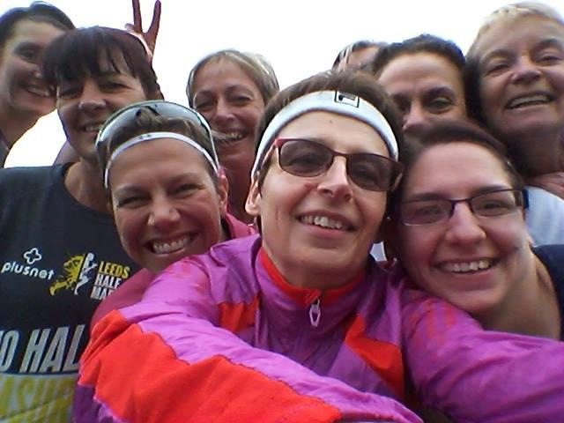

In preparation for the two 24 hour races that some of us are doing, me and zoe organised a running day at our house, where we would arrange to run several times in the day and also eat and rest in between runs to mimic the conditions at 24 hour races. Nine of us (Jill C, Tracy, Jan, Lynne, Kristine, Maria, Linda, Zoe and me) started at 9.30am on a Saturday morning with a trail run from Hessle to Ferriby along the river bank, for just under seven miles. On returning home, we all tucked into the several types of flap jack that everyone had brought ☺. Lots of chatting followed, with Zoe doing a display of rolling lol!
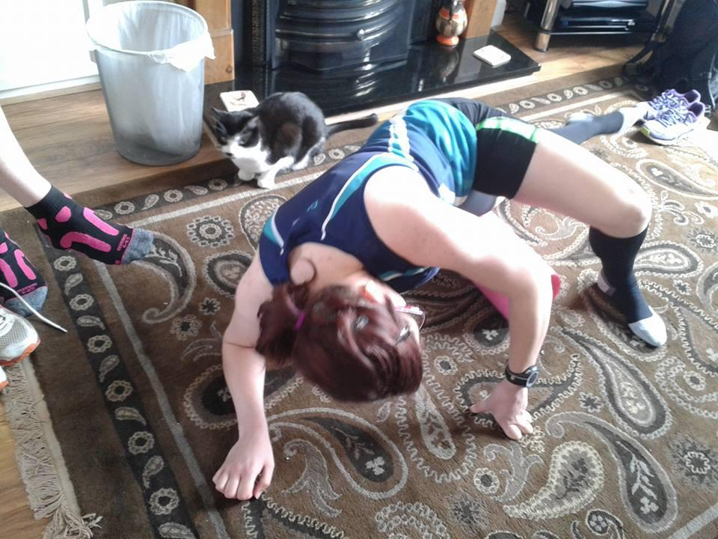
Lynne and Tracy went home after the first session and we were then joined by Sandra, who joined in with the rolling class!
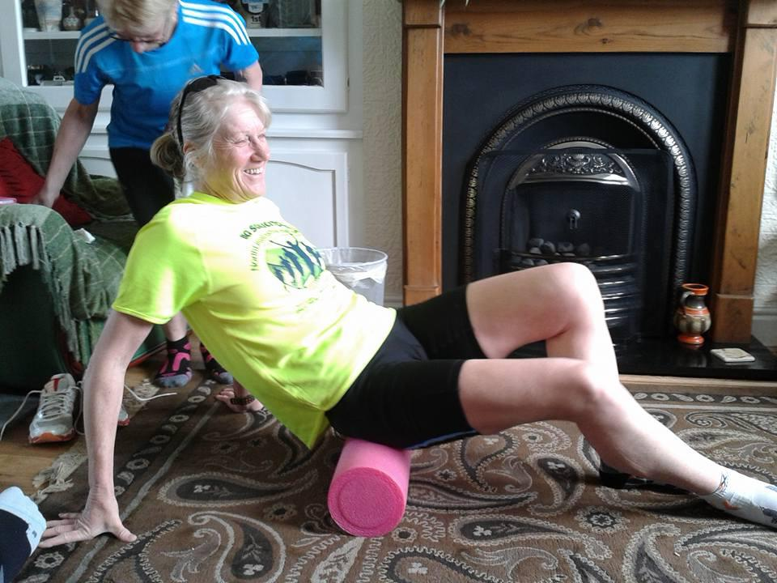
Our next run was to do most of the Humber Bridge 10k course. For me, this was the most enjoyable run of the day, as the sun had come out, and we were all well warmed up. Everyone was running really strongly, even up the hills, which were as tough as usual on the bridge.
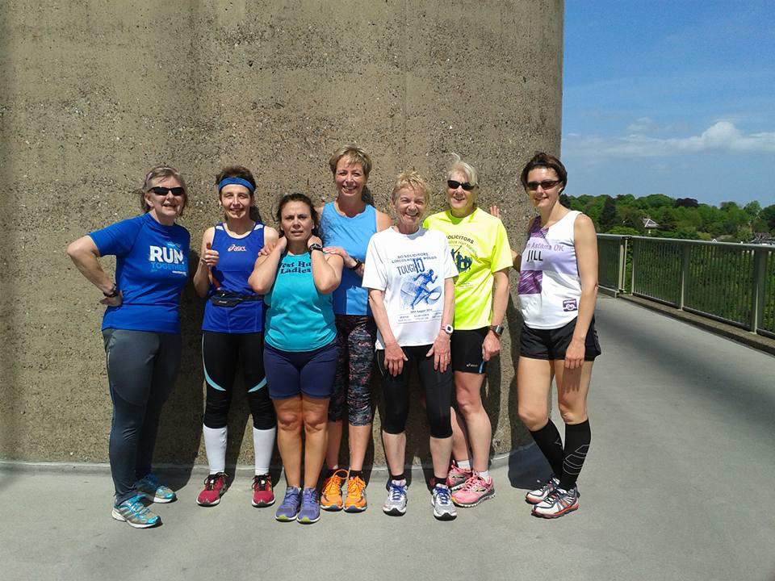
This run was around seven miles. We were really pleased to get back to the house, because we then had dinner, which was a feast that everyone had contributed to. Stuffed Peppers, Spanish Omelette, Lentil bake, home made bread, more flapjack…We had to be careful not to eat too much! After this it was quite difficult to motivate ourselves to go and run again, but being the ultimate professionals that we are (or are we just mad?)…we set off again, this time after having said goodbye to Jill C and Sandra.
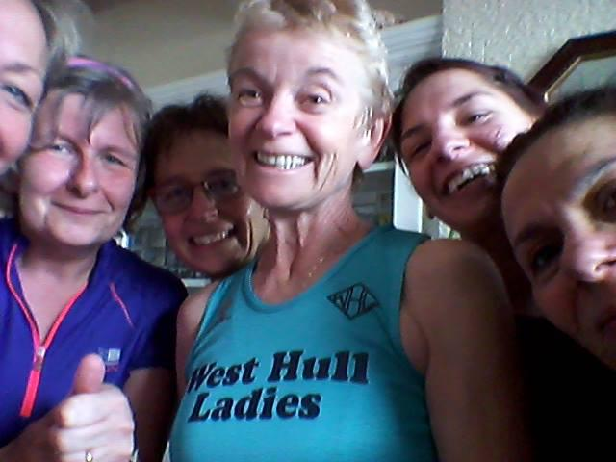
This time it was quite tough. We had decided to keep to a flat route up towards Pickering park and then back into Hessle along Boothferry road. Apart from speed freak Linda, I think we were all feeling a bit the worse for wear, but we dug in, and did some more miles to give a total of 18 miles in all over the day. This was a really good achievement particularly as it’s the furthest Kristine and Maria have run!
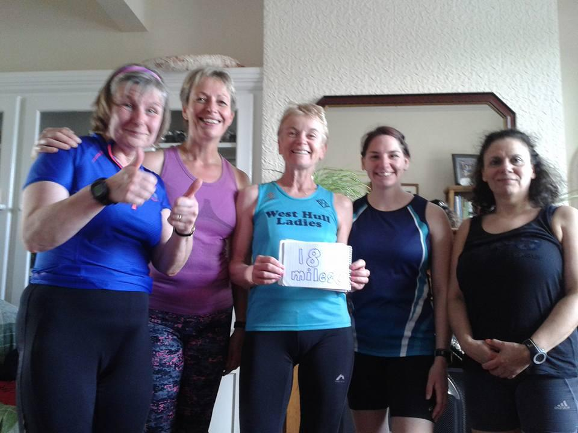
Zoe liked the vest that we have on trial for a possible new West Hull Ladies kit, as it didn’t ride up, or chafe. All in all, I think we all had a great time, even though it was tough at times, but it was all worth it for the food and flapjack, and the great opportunity to chat about lots of things… and the weather was really good…lets hope that Summer is here at last!
Jill xx

The Great British Relay

The Great British Relay is a true celebration of running and is the longest continuous unbroken running event lasting some 740hours - about 31 days.

It is split into 595 stages and covers over 7000km travelling around the coastline of mainland Britain. It starts in June and finishes sometime in July.

This is the second year that West Hull Ladies have participated in this wonderful event claiming stage 582. This stage requires us to pick up the ‘baton’ from Barton at 3.37pm on 1st July and run with it to Manchester Street off Hessle Road.

Although things may alter a little we hand it over to the next runner at 4.43pm.

The route is just short of 7 miles and how we did it last year was to have our fastest runners collect the baton in Barton and then meet others at the Humber Bridge car park and then Hessle Square. This should also work this year and enables everyone who wants to participate to be able to do so.

We had a great time in 2014 and I am sure we will this year. We have had quite a few ladies interested so if you haven’t already got the afternoon free maybe its time to think about it.

After we have handed the baton over Jill has kindly invited us back to her home for a celebratory cup of tea. Sounds good to me as I am sure cake will be involved somewhere along the line.

So if you haven’t already let Sandra know you are joining us please do so - the more the merrier.

There is also a T-shirt available to buy costing £12 and they come in Artic White, Desert Sand, Electric Pink, and Sunshine Yellow. The price is the same whether or not you want your name printed on or not.

Sizes are XS S M L XL XXL
8 10 12 14 16 18

Please let Sandra know if you want one and what size/colour. An email will be put out prior to the order going in asking for the money to be paid into the Clubs bank.

If you need any more information please ask or look on the website www.gbrelay.com

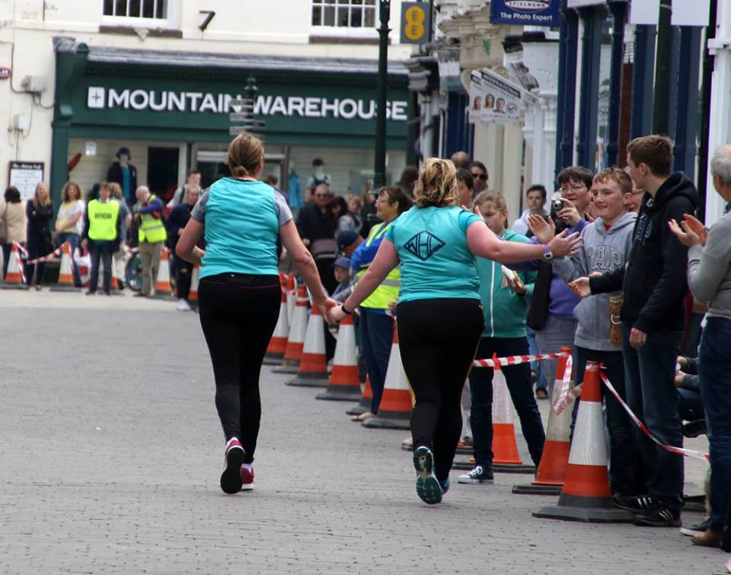

Team work at Beverley

2015 RACE DIARY
http://westhullladies.org.uk/races.htm

Free 5K time trial every Saturday 9am: Hull Parkrun or Peter Pan Parkrun Humber Bridge parkrun

June 2015
 | 12th/19:30 | Sledmere Sunset Trail 10K | £13 UKA/£15 | Online entries only | online entry
 | 13th/10:00 | Lincolnshire Wolds Tough Ten | £18.50 UKA/£20.50 | Online entries only | online entry
 | 14th/09:30 | Jane Tomlinson Hull 10K | £23.82 UKA/£25.82 | Online entries only | online entry
 | 21st/10:30 | Owstone Ferry 10K | £12 UKA/£14 | Online entries only | online entry
 | 21st/11:00 | Burton Pidsea 10K | £11 UKA/£13 | Online entries only | online entry
 | 28th/09:00 | Humber Bridge Half Marathon | £22 UKA/£24 | Online entries only | online entry
 | 28th/09:30 | Jane Tomlinson Pennine Lancashire 10K | £19.26 UKA/£21.40 | Online entries only | online entry
July 2015
 | 5th/10:00 | Caistor 10K | £10 UKA/£12 | Online entries only | online entry
 | 5th/10:30 | Harrogate Town Centre 10K | £10 UKA/£12 | Online entries only | online entry
 | 10th/19:30 | Walkington 10K | £11 UKA/£13 | Online entries only | online entry
 | 12th/09:30 | Jane Tomlinson Leeds 10K | £25.82 UKA/£27.96 | Online entries only | online entry
 | 19th/10:00 | Burton Constable Hall 10K Trail Race | £15 UKA/£18 | Entry form | online entry
August 2015
 | 2nd/09:30 | Jane Tomlinson York 10K | £25.82 UKA/£27.96 | Online entries only | online entry
 | 16th/11:00 | Escrick 10K | £12 UKA/£14 | Entry form | online entry (+£1.70)
 | 23rd/10:00 | Major Stone Half Marathon | £18.20 UKA/£20.20 | Online entries only | online entry
 | 30th/09:00 | Jim Dingwall 10K | £13 UKA/£15 | Online entries only | online entry
September 2015
 | 13th/09:00 | Hull Marathon | £35 UKA/£37 | Online entries only | online entry

Please remember to double check dates, times and entry fees with the official website or the entry form.

Keep checking the website for new races and updates:

NOTE: Club Vests must be worn at any races you enter
under the West Hull Ladies running club name.

West Hull Ladies Road Running Club
Kit Order Form

FORENAME ___________________________________

SURNAME ___________________________________

ORDER - tick what you require and circle your size Price
- VEST SIZE 10 12 14 16 £16.00
- LONG SLEEVED SIZE 10 12 14 16 £18.50
- HOODIE SIZE XS S M L £20
- HOODIE with ZIP SIZE XS S M L £20
Note on size, M is approximately size 14
- BEANIE HAT £6.50
- PINLESS WHL NUMBER FASTENERS (set of 4) £3.00

DATE Ordered _______________

AMOUNT PAID _______________

Please transfer payments online with your name and marked as ‘Kit to:
Account: 63762742 Sort Code: 20 43 49

Or cheque payable to ‘West Hull Ladies RRC’, and write your name and ‘Kit’ on the back and give to Club Treasurer Linda Dodsworth, 110 The Stray, South Cave, E Yorkshire. HU15 2AL

Sign on receipt of goods _________________________________
DATE _______________

Please complete this form and email to diazmaria@btinternet.com
Thanks.
Maria Kit Officer

